INDUSTRIAL ENGINEER VACANCIES
Who is InSync Solutions?
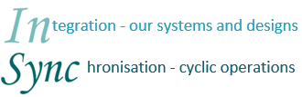
InSync Solutions is a Logistical Solutions provider that makes significant contributions to the supply chains of its customers through their unique processes & systems to improve speed & control at reduced cost & risk.
InSync Solutions specialises in Warehouse design and management including processes, systems and people.

Positions available:
- Junior Industrial Engineers (B.Eng/B.Sc in Industrial Engineering)
- Industrial Engineers with 3 – 4 years’ experience (B.Eng/B.Sc in Industrial Engineering. Experience in Warehousing will be an advantage.)

Locations:
- East London
- Johannesburg

Why you should join InSync Solutions:
You will be joining an elite team of Industrial Engineers who works in ideal conditions to develop as Industrial Engineers. With InSync Solutions still being a fairly young company which has shown steady growth over the past years, career development opportunities are good.

Next Step...
Send a summarised version of your CV to neels@insyncsolutions.co.za

